Introduction to DBMS and Relational Model

Contents

1. Introduction Database Management System 2

Types of Database Management Systems 3

2. Key 4

Types of keys 4

Super Key: 4

Candidate Key: 4

Primary Key: 5

Foreign Key: 6

SQL Used 6

3. Schema Design 8

Anomalies 8

Insertion Anomaly 8

Deletion Anomaly 9

Update Anomaly 9

Database Normalization 10

How to do Schema Design in Practice 10

Code and Notes are @ <https://github.com/nishithjain/Design_Pen>

# Introduction Database Management System

* What is a database?
  + Let's split the word Database into two. Data & Base.
  + What is a base?
    - The part on which it stands. So, database means, where data resides.
  + It is not random data, but it is organized collection of interrelated data around a particular use case.
    - For example: An educational institute might store data about students, classes, batches. These data are interrelated.
* What is Database Management System?
  + We need to manage the data, like, update the existing data, delete the data.
  + We need a system to do it efficiently.
* Why do we need DBMS?
  + If we were to store the data in files.
    - **Data Redundancy and Consistency**: Data is often duplicated in different files, leading to inconsistency when one file is updated, but others are not.
    - **Data Integrity**: Maintaining data integrity (e.g., ensuring data types or constraints) is difficult and must be manually managed.
    - **Data Security**: Files offer limited or no mechanisms to restrict access, making it harder to implement granular security policies.
    - **Concurrency Control**: Handling simultaneous access by multiple users can lead to conflicts (e.g., data corruption, overwriting issues).
    - **Data Backup and Recovery**: You must manually manage backups, and recovery in case of failures is challenging and error-prone.
    - **Efficient Query Processing**: Retrieving specific data from large files requires scanning the entire file, which can be slow and inefficient.
    - **Data Independence**: Changing the structure of files often requires changes to the application code.
    - **Data Relationships**: Managing relationships (e.g., between customers and orders) is complex and prone to errors.
    - **Performance Optimization**: Performance tuning (e.g., indexing, caching) requires custom implementation, which can be inefficient.

## Types of Database Management Systems

* Types are characterized by 2 things.
  + How they store the data.
  + What requirements do they fulfill.
* Relational DBMS (SQL database)
  + A database system that follows the **relational model** to store data.
  + Example: MySQL, Postgres, Oracle SQL
* Non-Relational DBMS (No SQL database)
  + Example:
    - Key-Value: Redis
    - Document Model: MongoDB
    - Columnar: Casandra
    - Graph: Neo4J
* What is Relational Model?
  + Relational Model is a type of data model.
  + Data model is collection of concepts that we use to describe data in database. Concepts are nothing but tables, schema, key, etc...
* Mathematical Definition of Relational Model.
  + The database is represented as a collection of multiple relations. Each relation will have a set of tuples and these may be related to a tuple in another relation.
    - Here relation is nothing but tables. There for, the database is represented as a collection of multiple tables.
  + Let's see properties of a relation (table)
    - The definition says, each relation will have set of tuples. Here tuple means row.
  + The definition also says 'set of tuples'. Set has 2 properties:
    - No duplicates are allowed in set.
    - Order doesn't matter in set. Order of columns also doesn’t matter.
  + Value in each cell is atomic.
    - No multivalued cell such as list, JSON, array.

# Key

* Some set of columns whose values will be present in exactly in 1 row.
* Set of columns that help to uniquely identify a row.
  + Example: A Table Student has name, email, phonenumber as columns, we can consider email as key. Because, email is unique.
* A key must present in every row.

## Types of keys

### Super Key:

* A set of columns whose values can be used to uniquely identify a single row.
  + 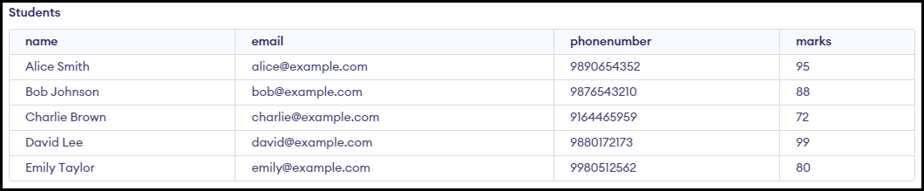Example: A Table Student has name, email, phonenumber, marks as columns as shown below…
  + Candidates for super key are email, phonenumber, {name, email}, {name, phonenumber}, {email, phonenumber}.

|  |  |
| --- | --- |
| Column Name | Is Super Key |
| name | ✗ |
| email | ✓ |
| phonenumber | ✓ |
| marks | ✗ |
| {name, marks} | ✗ |
| {name, email} | ✓ |
| {name, phonenumber} | ✓ |
| {email, phonenumber} | ✓ |

### Candidate Key:

* A Super key of minimum size such that if we remove any column from it, the remaining columns is no longer a super key. In other words, a candidate key is a super key that does not have any unnecessary columns.
* A table can have more than one candidate key. When this happens, one of them is usually chosen as the primary key.
  + Example: We have a table student_marks, which has the data for every student, for every exam they gave, we are storing their marks.

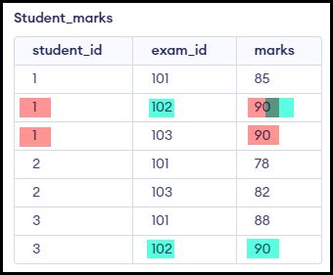

|  |  |  |  |
| --- | --- | --- | --- |
| Column Name | Is Super Key | Comments | Is Candidate Key |
| student_id | ✗ |  | Should be Super Key |
| exam_id | ✗ |  | Should be Super Key |
| marks | ✗ |  | Should be Super Key |
| {student_id, marks} | ✗ | Same student can have same marks in different exam. | Should be Super Key |
| {exam_id, marks} | ✗ | 2 students can have same marks in same exam. | Should be Super Key |
| {student_id, exam_id} | ✓ | 1 student can take a particular exam only once. | ✓ |
| {student_id, exam_id, marks} | ✓ | 1 student, 1 exam, marks. | ✗ |

* Every super key is a candidate key? No
* Every candidate key is a super key? Yes

### Primary Key:

* We don't want useless columns in Primary key. Hence, primary key is any one of the candidate keys that is specified as a key when creating a new table.
  + Database enforces no 2 rows have duplicate values in those set of columns (Primary key columns).
  + Database will not allow empty values in those columns (Primary key columns).
* If we create a table Student with only Name as column. Since we should have a primary key column. We must create another column as ID column as primary key.

### Foreign Key:

* Allows us to uniquely identify a row of another table.
* We have use cases where we want to store relation between multiple tables.

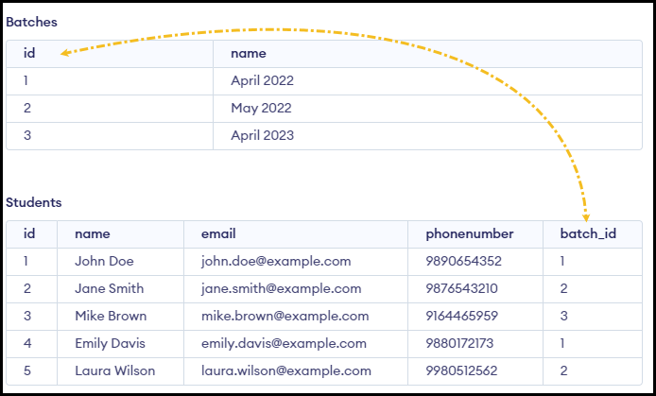

### SQL Used

|  |
| --- |
| CREATE TABLE students (      name VARCHAR(100) NOT NULL,      email VARCHAR(100) NOT NULL UNIQUE,      phonenumber VARCHAR(15) NOT NULL,      marks INT CHECK (marks >= 0 AND marks <= 100)  );  INSERT INTO students (name, email, phonenumber, marks)  VALUES ('Alice Smith', 'alice@example.com', '9890654352', 95);  INSERT INTO students (name, email, phonenumber, marks)  VALUES ('Bob Johnson', 'bob@example.com', '9876543210', 88);  INSERT INTO students (name, email, phonenumber, marks)  VALUES ('Charlie Brown', 'charlie@example.com', '9164465959', 72);  INSERT INTO students (name, email, phonenumber, marks)  VALUES ('David Lee', 'david@example.com', '9880172173', 99);  INSERT INTO students (name, email, phonenumber, marks)  VALUES ('Emily Taylor', 'emily@example.com', '9980512562', 80);  CREATE TABLE IF NOT EXISTS student_marks (      student_id INT NOT NULL,      exam_id INT NOT NULL,      marks INT CHECK (marks >= 0 AND marks <= 100)      );    INSERT INTO student_marks (student_id, exam_id, marks) VALUES  (1, 101, 85),  (1, 102, 90),  (1, 103, 90),  (2, 101, 78),  (2, 103, 82),  (3, 101, 88),  (3, 102, 90);  drop table students;  drop table student_marks;  CREATE TABLE IF NOT EXISTS batches (      id INT PRIMARY KEY,      name VARCHAR(50) NOT NULL  );  -- Insert some rows into the batches table with manual IDs  INSERT INTO batches (id, name) VALUES  (1, 'April 2022'),  (2, 'May 2022'),  (3, 'April 2023');  CREATE TABLE IF NOT EXISTS students (      id INT PRIMARY KEY,      name VARCHAR(100) NOT NULL,      email VARCHAR(100) NOT NULL UNIQUE,      phonenumber VARCHAR(15) NOT NULL,      batch_id INT,      FOREIGN KEY (batch_id) REFERENCES batches(id)  );  -- Insert some rows into the students table with manual IDs and batch associations  INSERT INTO students (id, name, email, phonenumber, batch_id) VALUES  (1, 'John Doe', 'john.doe@example.com', '9890654352', 1),  (2, 'Jane Smith', 'jane.smith@example.com', '9876543210', 2),  (3, 'Mike Brown', 'mike.brown@example.com', '9164465959', 3),  (4, 'Emily Davis', 'emily.davis@example.com', '9880172173', 1),  (5, 'Laura Wilson', 'laura.wilson@example.com', '9980512562', 2); |

# Schema Design

* As a software developer, we do prepare design document.
  + Class Diagram - How will you implement application. (LLD)
  + Architectural Diagram - What infrastructure layers will be there. (HLD)
  + Schema Design - What tables will be there in our Database.
* Database Schema:
  + How will you store the data to be able to handle the given set of requirements.
  + Schema is blueprint of a real database. A pictorial representation of how database is going to be structured.
* Why do we need Schema design?
  + Should be able to handle all the requirements.
  + Handle requirements efficiently.
  + Avoid anomalies (issues such as redundancy which can cause inconsistency and more storage).

## Anomalies

* Issue due to redundancy.
* There are 3 types of anomalies...
  + Insertion anomaly
  + Deletion anomaly
  + Update anomaly
* When we have redundancy in database these anomalies happen.

### Insertion Anomaly

* Suppose there is a table Students with id, name, marks, batch_id, batch_name as columns as shown below...

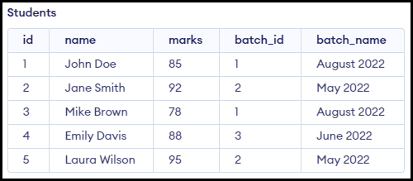

|  |
| --- |
| CREATE TABLE IF NOT EXISTS students (      id INT PRIMARY KEY,      name VARCHAR(100) NOT NULL,      marks INT CHECK (marks >= 0 AND marks <= 100),      batch_id INT NOT NULL,      batch_name VARCHAR(50) NOT NULL  ); |

* New requirement has come: Create a new batch named December 2022. No students in that December 2022 batch yet.
* Since, no students are present in that batch, it is not possible to create a new row (id is primary key, name cannot be null.)
* Is this table Students is correctly created? Answer is no. There is lot of redundancy in the table.
* The batch_name column has redundancy. Note that 'August 2022' is repeated many times. Because of this redundancy we have insertion anomaly.
* Insertion anomaly is *inability to store data about a particular entity till the time we have data about something else*.

### Deletion Anomaly

* New request has come. We need to delete the student with id 4 (Imagine that this student has registered for June 2022 batch first and is the only student in that batch)
* If we delete that student, the batch information is also deleted. Note that the student with id 4 is in June 2022 and there is only 1 student in that batch.

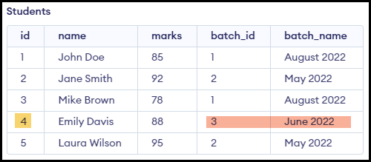

* Deletion anomaly is, at the time of deleting something, we might end up deleting something else.

### Update Anomaly

* A new requirement has come where we need to change the batch_name 'August 2022' to 'Aug2022'.
* Imagine, we have written a query to update from 'August 2022' to 'Aug2022'. After updating couple of rows, machine has gone down… The state of table will look as show below…

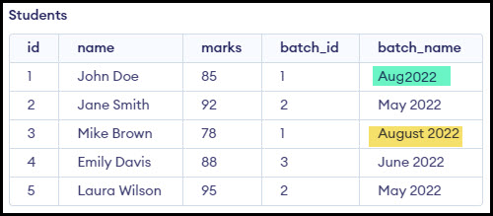

* Update anomaly is, at the time of updating something, we might end up in inconsistencies.

### Database Normalization

* It is the techniques that we use to handle redundancy.
* There is something called normal forms. Normal forms are guidelines used in database design to reduce redundancy and improve data integrity by organizing data into tables.
  + 1NF
  + 2NF
  + 3NF
  + 4NF
  + 5NF
  + 6NF
  + BCNF (Boyce Codd Normal Form)
* We don’t use these NF in practice. We never use normal forms in reality. There is more practical way to approach database design.

### How to do Schema Design in Practice

* Schema design of Scaler.
* Let's list out the requirements.
  + Scaler has multiple students.
  + Scaler has multiple batches. Each student belong to exactly one batch at a time. one batch can have multiple students.
  + Every batch has a current instructor.
  + Every batch has multiple classes.
  + 1 class may involve students from multiple batchs
  + Every student has a student buddy.
  + Every student has a mentor.
  + For every mentor we store their company and number of session the mentor has taken.
  + We have to store for every batch a student belong to, date of joining that batch.
  + For every student for every class we have to store attendance.

#### Steps

1. Find all the nouns that are there in the requirements.
   * Out of all the nouns find the nouns that we want to store information about.
   * Create 1 table for each such noun.
   * Good Practices:
     + Name of each table should ideally plural.
     + Represent table name in snake case. (Example: mentor_sessions)
   * Nouns identified:
     + students
     + batches
     + instructors
     + classes
     + mentors
     + companies
2. For each of these nouns, find what all we need to store.
   * Create an id column
   * If no realation with another noun, create a column for that (primitive attributes). For example, Students will have name and name has no relation with other nouns. Hence it is a primitive attribute.

|  |  |
| --- | --- |
| CREATE TABLE students (      id INT PRIMARY KEY,      name VARCHAR(100) NOT NULL,      email VARCHAR(100) UNIQUE NOT NULL,      phone_number VARCHAR(15),      graduation_year INT  ); | CREATE TABLE batches (      id INT PRIMARY KEY,      name VARCHAR(100) NOT NULL,      start_date DATE,      number_of_students INT  ); |
| CREATE TABLE instructors (      id INT PRIMARY KEY,      name VARCHAR(100) NOT NULL,      email VARCHAR(100) UNIQUE NOT NULL,      average_rating DECIMAL(3, 2),      years_of_experience INT  ); | CREATE TABLE classes (      id INT PRIMARY KEY,      start_time TIME,      title VARCHAR(100),      endtime TIME  ); |
| CREATE TABLE mentors (      id INT PRIMARY KEY,      name VARCHAR(100) NOT NULL,      email VARCHAR(100) UNIQUE NOT NULL,      number_of_mentees INT,      average_rating DECIMAL(3, 2)  ); | CREATE TABLE companies (      id INT PRIMARY KEY,      name VARCHAR(100) NOT NULL  ); |

1. Now we have to represent relations.
   * But how to represent relation?
   * For relation,
     + Which two tables are related.
     + What relation between entities (Find cardinality).

* What is Cardinality?
  + *Cardinality* refers to the relationship between two entities. It defines how entities in one table relate to entities in another.
  + Let’s say we have Students and Batches
    - 1 Student is allotted to 1 Batches.
    - 1 Batches can have multiple Students.

* + Let’s say we have Husbands and Wifes table
    - 1 husband has 1 wife.
    - 1 wife has 1 husband.

* There are 4 types cardinality :
  1. 1:1
  2. 1:m
  3. m:1
  4. m:m
* Steps to find the cardinality…
  + Let’s say we have Movies and Shows table…
    - Go from Left to right and ask the question 1 movie how many shows?

* + - Go from Right to left and ask the question 1 show can have how many movies?

* + - If there no m, put 1 else put M.

* For relation in column, if cardinality is
  + 1:1, id of any 1 side on other side.
  + M:1, id of 1 side on m side. (Because we can have a list on 1 side and we cannot store list)
  + 1:M, id of 1 side on m side. (Because we can have a list on 1 side and we cannot store list)
  + M:M, Mapping table. (We have to create a new table, because there will be list on both sides)

* + - We create a new table, Student_Course with student_id, courese_id as columns.